DBU octanoate SA-102

summary:

Product name: Polyurethane catalyst SA-102

Alias: DBU octanoate, SA102, Niax A-577, tertiary amine reactive delayed catalyst SA-102, reactive delayed catalyst SA-102, delayed catalyst SA-102, tertiary amine reactive catalyst SA-102

Product description: SA-102 is a tertiary amine reaction type delayed catalyst

Product properties:

Appearance: light yellow liquid

Viscosity (25 ℃, mPa. s): 460

Density (25 ℃, g/cm3): 1.09

Water solubility: soluble in water

Flash point (PMCC, ℃): 104

Hydroxyl value (mgKOH/g): 1516

DBU octanoate tertiary amine reactive type delayed catalyst SA-102 reactive type delayed catalyst SA-102 delayed catalyst SA-102 tertiary amine reactive type catalyst SA-102

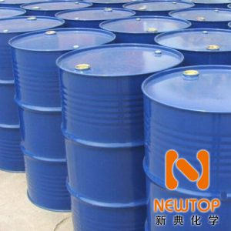

Product use:

Catalyst SA-102 is a tertiary amine reaction type delay catalyst, which can strongly promote the reaction of carbamate (polyol isocyanate) in microporous foam, hard foam, self skinning foam, coating, adhesive, sealant and elastomer under the effect of thermal activation;

The catalyst SA-102 is suitable for products that require a certain delay at the beginning and then ripen quickly. SA-102 will not participate in the reaction at the beginning. The heat released from the carbamate reaction or urea reaction will enable SA-102 to quickly unseal. The unsealed material will quickly catalyze the carbamate reaction, so that the product can quickly solidify;

The thermal sensitive temperature of catalyst SA-102 is 60 ℃, which can extend the opalescence time and rapidly demould.

DBU octanoate tertiary amine reactive type delayed catalyst SA-102 reactive type delayed catalyst SA-102 delayed catalyst SA-102 tertiary amine reactive type catalyst SA-102

quality guarantee period:

The unopened shelf life is 12 months.

Storage and transportation:

It shall be sealed and stored in a dry, cool and ventilated warehouse

packing:

200KG/barrel storage: It is recommended to store in a dry and cool area with proper ventilation. Please fasten the package cover as soon as possible after the original packaging, so as to prevent the mixing of other substances such as water and affect the product performance. Store in a cool, dry place and keep the container sealed to avoid contact with oxides. Do not breathe dust and avoid skin and mucous membrane contact. Smoking, eating and drinking are prohibited in the workplace. After work, take a shower and change clothes. Store contaminated clothes separately and reuse them after washing. Keep good hygiene habits. The company recommends that all polyurethane catalysts be stored in a dry, cool and properly ventilated place. All storage containers must be well sealed to avoid contact with water or other influential substances, because this may change the performance of the product in use. The storage temperature is 10 ℃ to 30 ℃. Lower or higher temperatures are inappropriate and should be avoided as much as possible.